Extra 10-1 Use Bootstrap to enhance the Reservation application

In this exercise, you’ll use Bootstrap to enhance the Reservation application. This will change the appearance of the pages to something like the one that follows. Here, the application has a navbar that uses glyphicons, the logo image is styled by Bootstrap so it’s responsive, and the copyright text is styled by Bootstrap rather than custom CSS. Finally, the Contact Us page shown here and the Rooms page (not shown) use Bootstrap components to display their information.

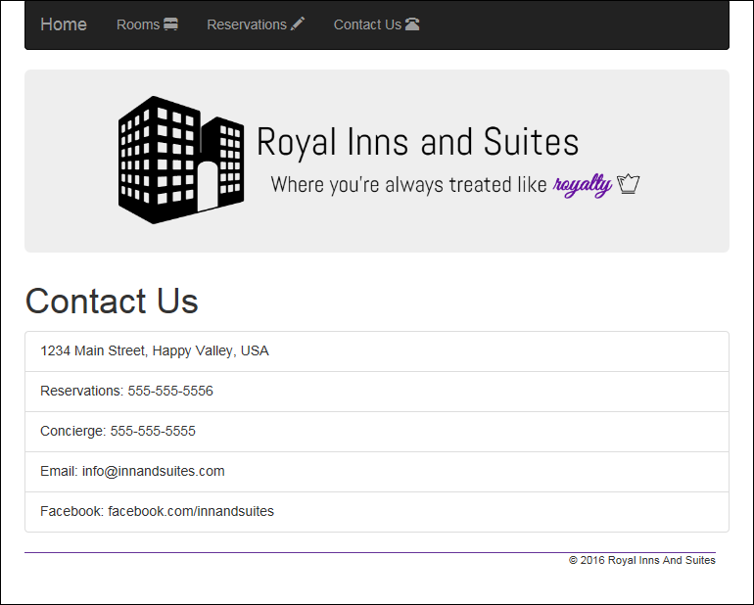

Run and test the application

1. Open the XEx10Reservation web application from D2L. You will need to paste your code from site.master, request.aspx, request.aspx.cs, confirm.aspx, confirm.aspx.cs and then make sure those files work correctly.
2. After you have your Site.Master up and running, paste the navbar section in right before the <header>.
3. Click on all the links in the navbar and see how the pages look. In particular, notice that the copyright notice in the footer looks off, as do the radio buttons on the Reservations page. Also notice that the Rooms and Contact Us pages could benefit from some additional formatting.
4. Make the browser as narrow as possible. Notice that the logo image doesn’t scale when you do this. Rather, it just scrolls off the page as the viewport narrows.

Use Bootstrap CSS classes to enhance the application

For the remainder of this exercise, if a step tells you to view your changes, save the changes in Visual Studio, switch to the running browser, and then refresh the browser.

1. In the master page, find the logo image in the header element and assign the Bootstrap img-responsive class to it. Then, view your changes and narrow the browser again. This time, the logo image scales relative to its parent.
2. Still in the master page, find the copyright information in the footer element. Put the copyright text inside a span tag. Then, assign Bootstrap text CSS classes to move the copyright information to the right and to capitalize each word. View your changes.
3. Navigate to the Reservations page in your browser, and then open the Request.aspx file in Visual Studio. Find the bed type radio buttons and enclose each one in a label element. Then, assign the Bootstrap radio-inline CSS class to each label. View your changes.
4. Complete the reservation form and click the Submit button to display the Confirmation page. Open the Confirm.aspx file in Visual Studio and find the two table elements. Assign Bootstrap table CSS classes to each so the tables have borders and are condensed. View your changes.

Use Bootstrap components to enhance the application

1. Navigate to the Contact Us page in your browser, and then open the ContactUs.aspx file in Visual Studio. Find the unordered list that contains the contact information. Then, convert that list to a Bootstrap list group component. View your changes.
2. Navigate to the Rooms page in your browser. Make the browser as wide and as narrow as possible and see how the images behave.
3. Open the Rooms.aspx file in Visual Studio and find the images and text for each room. Then, make a thumbnail component with captions for each room, and center the text in the captions. View your changes, and widen and narrow the browser to see how the images behave now.
4. In a different browser, go to the Bootstrap URL at the top of figure 10-7, navigate to the Glyphicons section, and select three glyphs to use for the Rooms, Reservations, and Contact Us navigation links. (Note: You don’t need to choose the same glyphs as those shown above.) Then, in the master page, add the glyphs to the navbar. View your changes.
5. Still in the code for the navbar, make the navbar an inverse navbar. View your changes.

Change the application to use a theme from the Bootswatch website

1. In a different browser, go to the URL for the Bootswatch website at the top of figure 10-17. Scroll down to view the free themes, and pick one you like.
2. Click on the Download button for the theme you want, and save the minified version of the CSS file to the Content folder of your web application. Be sure to include the name of the theme in the name of the CSS file so it doesn’t overwrite the original Bootstrap CSS file.
3. In the master page, change the link for the Bootstrap CSS file to refer to the CSS file you just downloaded. View your changes.
4. Optionally, open the site.css file and comment out the rule sets for the btn-primary class so you can see how the btn-primary class for the new theme looks in your application. View your changes.